**Project checkpoint 4: SQL queries and interface**

1. **SQL queries**

In this checkpoint, you will write a set of SQL queries and stored procedures to use in your application. Based on your project description and domain, write at least **12 SQL queries** and **3 store procedures** OR 15 **stored procedures** that you will be using in your database application. You should have at least 9 queries or queries in your procedures at levels 2 or 3.

| SQL query level requirement | Description |
| --- | --- |
| Level 1 | Standard SQL queries using only one table. |
| Level 2 | SQL queries on **multiple tables** that join with each other or subqueries involve **more than one table**. Use group by, having, order by, built-in functions if applicable. |
| Level 3 | Queries in level 2 and one of the followings:  - Complicated calculation needed  - Subquery in FROM clause  - Self-join  - Nested subquery in WHERE clause  - Anything that goes beyond simple group by/having/order/built-in functions. |

| SQL Query or Stored Procedure | Functionality in Database | lvl |
| --- | --- | --- |
| delimiter $$​  drop procedure if exists getJob_byTitle;​  create procedure getJob_byTitle(IN JobTitle varchar(255) ) ​  begin ​  Select * from Job where Job_Title like CONCAT('%’, JobTitle, ‘%');  end $$​  delimiter ; | Search job listings by the title | 1 |
| “Select * from Job j where Job_Title like ‘%“ + userinput + “%’ AND j.C_Name = (select c.C_name from Company where c.C_size =” + size +”);” | Search job listings by title and company size | 2 |
| “Select * from Job j where j.Qualifications like “+ userinputqualifications +” AND j.C_name IN ((select L.C_name from Location L where l.distance <= “+ userdistance +” ));” | Search jobs listings by distance and qualifications | 3 |
| “Select * from Job where C_name like ‘%”+ usercname + ”%’;” | Search job listings by company name | 1 |
| “Select C_name from Company where c_size >= “+ usersize +”;” | Search company by size | 1 |
| “Select * from Job j where min_salary = “+ usermin_sal +” AND j.JobID IN (select h.JobID from hosts h where w_domain like ‘%“+ domain +”%’);” | Search by website domain and min salary | 2 |
| “Select * from Job j where j.Job_Title like ‘%”+ userjobtitle +”%’  AND j.C_name IN ( select r.C_name from Recruiter r where r.R_name like ‘%“+ userinput +”%’ ) ; | Search job title by recruiter name | 2 |
| “Select * from Job j where j.min_sal >= “+ usermin +” AND j.max_sal >= “+ usermax +” AND j.C_name IN (select l.C_name from Location l where l.city like %”+ user_city +”%); | Search job by city and min and max salary | 2 |
| “Select * from Job j where j.C_name IN (select l.C_name from Location l where l.city like %”+ usercity +”% AND l.country like %”+ usercountry +”% )”; | Search jobs by city and country | 2 |
| “Select * from Job j where j.work_type like %”+ userworktype +”% AND j.min_sal>= “+ usermin +” AND j.max_sal >= “ + usermax +” ;” | Search by job type and salary within a range | 1 |
| “Select * from Job j where j.experience like %”+ userexperience + “%;” | Search job by experience | 1 |
| delimiter $$​  drop procedure if exists getJob_byExperienceCity;​  create procedure getJob_byExperienceCity(IN experience VARCHAR(255), city Varchar(255) ) ​  begin ​  Select * from Job j where j.experience like '%experience%'  AND j.C_name IN  (select l.C_name from location where l.City like '%city%');  end $$​  delimiter ; | Search jobs by experience & city | 2 |
| “Select * from Job j where j.skills like %”+ user_skills +”% AND j.C_name IN (select l.C_name from location where l.country like %”+ usercountry +”%);” | Search jobs by country and skills | 2 |
| “Select * from Job j where j.C_name like %”+ usercname +”% AND j.JobID IN (select h.JobID from Hosts h where h.w_domain like %”+ userwdoman +”%);” | Search jobs by Portal Domain and Company Name | 2 |
| delimiter $$​  drop procedure if exists getJob_byRecruiter;​  create procedure getJob_byRecruiter(IN Recruiter_phone varchar(255) ) ​  begin ​  Select * from Job j where j.C_name IN (select r.C_name from Recruiter r where r.Phone_Number like '%Recruiter_phone%');  end $$​  delimiter ; | Search jobs by recruiter phone number | 2 |

**2. Interface:**

Each group must submit a document that shows the screenshots of your database in action or mock-up of the interfaces (if the interfaces have not been finished yet). Show the screens of asking queries over the database, inserting data into various tables in the database, and modifying the data.

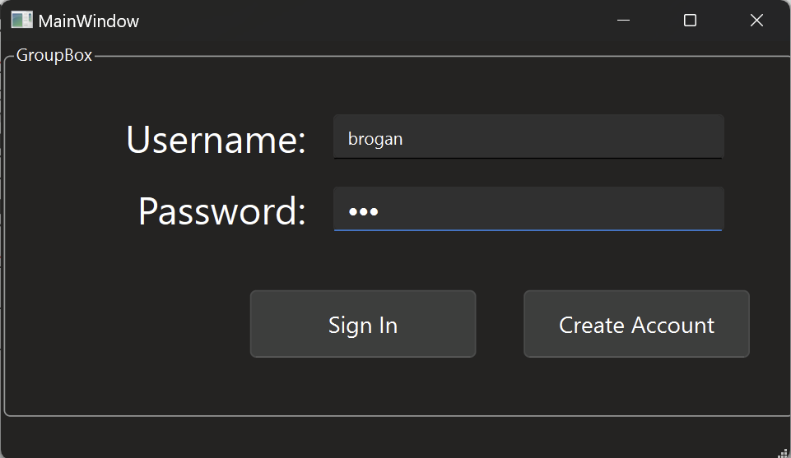

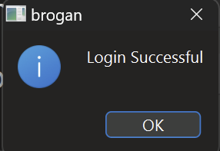

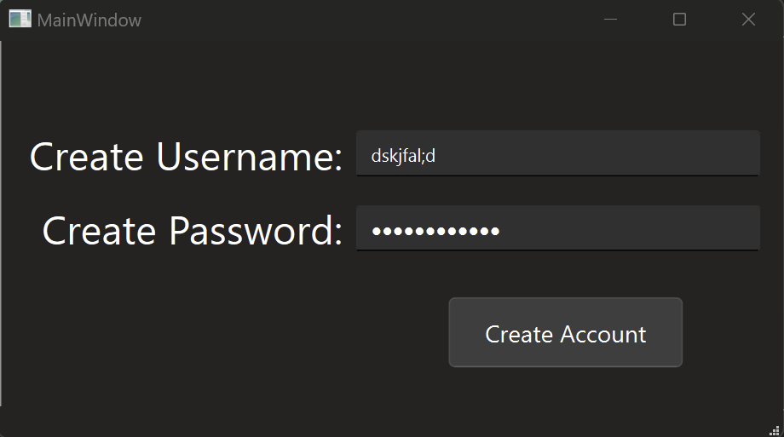

The account creation page and sign in page have been successfully created and implemented into the flow of the program. Future changes will be made to the font and color choices of the program, these are more proof of concepts.

The following mock-ups will be recreated in QT:

**Search page listed after login screen**

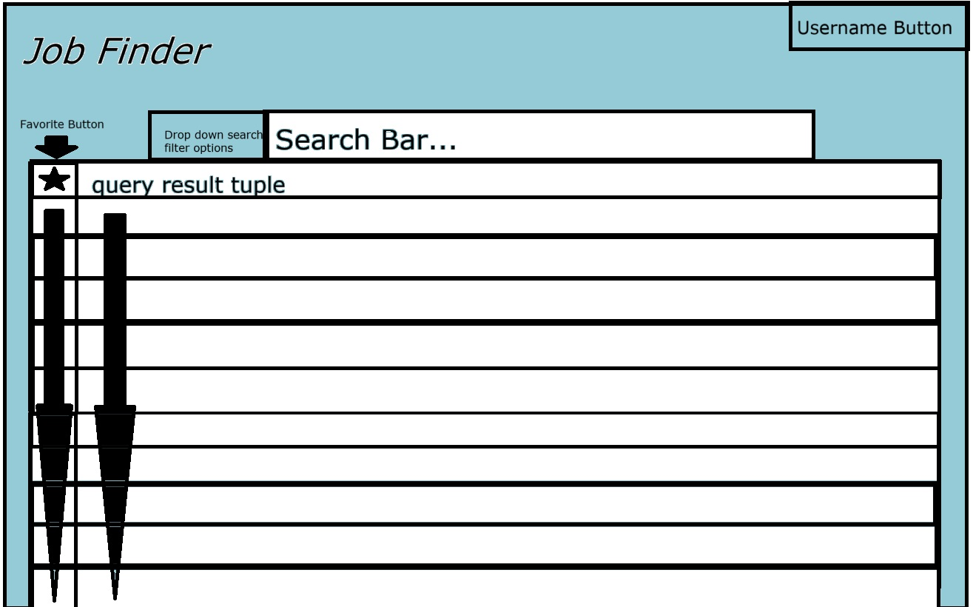

Favorite button: inserts tuple into the favorite’s tables, which is displayed on the user’s page.

**Account page**

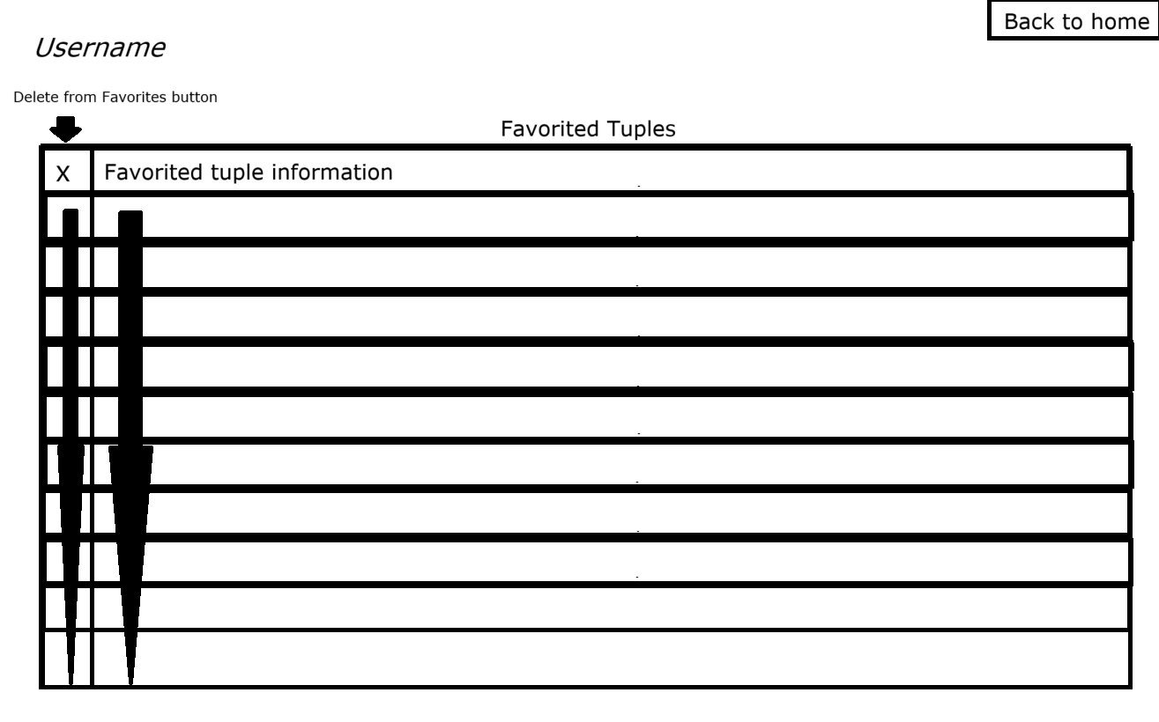

**Job page when listing is clicked:**